**Religion and Beliefs Guidance**

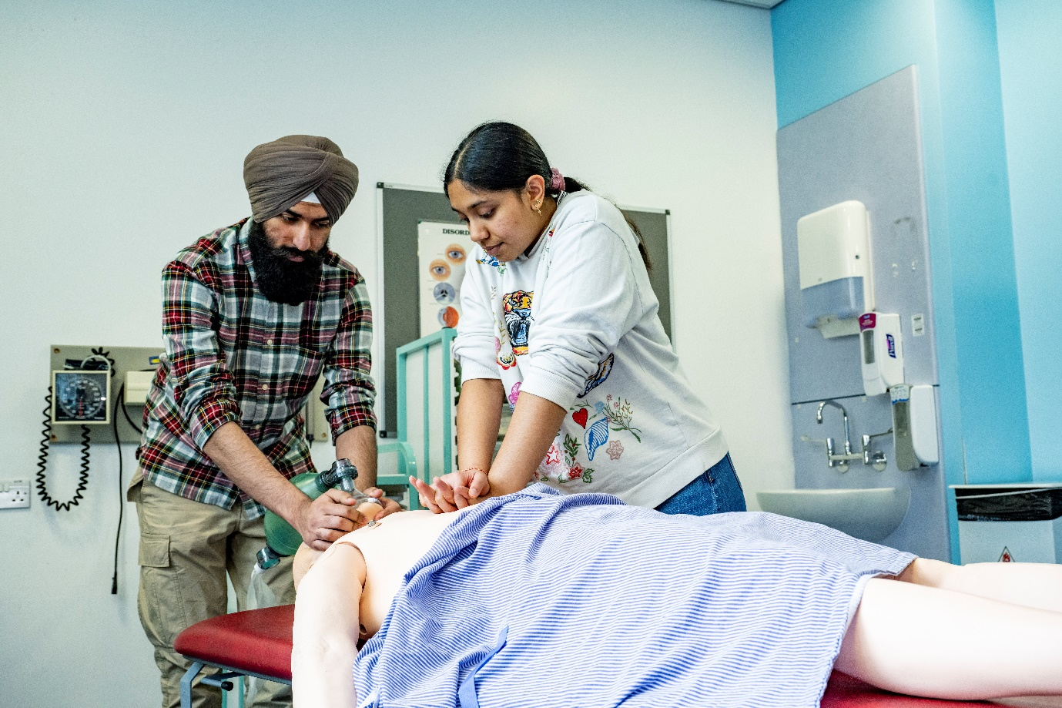

Contents

**Introduction** 4

**1.** **The importance of working with people of both sexes** 5

1.1 Sleeve length 7

**2.** **Scrubbing in** 7

2.1 Request for a reasonable accommodation 7

**3.** **Alcohol-based hand gel** 8

3.1 Muslim students and alcohol-based hand gel 8

**4.** **The Hijab or Headscarf** 8

4.1 Wearing the hijab 8

**5.** **The Turban** 9

5.1 Wearing the turban 9

**6.** **The Yarmulke** 9

6.1 Wearing the Yarmulke 9

**7.** **Face veil - Niqab and Burka** 10

7.1 Face veil 10

7.2 Loose dress - The jilbab and the chador 10

**8.** **Beards** 11

8.1 Beards and Facial Hair 11

**9.** **The Kara: Steel Bangle** 11

9.1 The Kara 11

**10.** **The Kirpan: Ceremonial Sword** 12

10.1 The Kirpan 12

**11.** **Suitable clothing for laboratory work** 12

11.1 Laboratory coats 12

11.2 Trailing clothes 12

11.3 Personal protective equipment 13

11.4 Modest Medical Wear 13

**12.** **Identification checks** 13

12.1 ID Security checks – please also see section 7.1 (the Niqab and Burka) 13

**13.** **Taking part in medical procedures** 14

13.1 Taking part in abortive procedures/human embryo/fertility treatments 14

**14.** **Practising your religion** 14

14.1 Practising your religion 14

14.2 Multifaith Societies 14

14.3 Food on campus 15

**15.** **Keeping a record of each student’s request** 15

15.1 Monitoring 15

**Acknowledgements** 15

# **Introduction**

The main aim of our education programmes in the Faculty of Medicine is to ensure students learn to become excellent health professionals. We focus on teaching skills which will enable students to provide outstanding healthcare to their patients and act as competent and helpful members of a healthcare team. We believe this safeguards future patient care, as well as helping students transition into the clinical environment.

We aim for all our students, from all walks of life, to feel welcome at the University and on placements. This “Religion and Beliefs guidance” outlines reasonable accommodations or considerations the faculty offers for reasons of religious and cultural observance. Such accommodations may be requested by students both within the university and while on placement.

It must be acknowledged that any reasonable accommodations and considerations made need to comply with policy and processes of individual NHS Trusts.

This guidance should be read in conjunction with the University of Southampton’s Religion and Belief Policy which can be found at [http://www.southampton.ac.uk/diversity/policies/religion_belief.page](http://www.southampton.ac.uk/diversity/policies/religion_belief.page%20) and the Faculty of Medicine’s Religious Holiday Guidance which can be found at: <https://blackboard.soton.ac.uk/ultra/courses/_152405_1/cl/outline>

Please see the Your Responsibilities section - religion and beliefs

**Requesting that a reasonable accommodation be made**

Should students wish to request a reasonable accommodation be made on placement, they should approach the Faculty Placement team who will liaise with the clinical sub-deans at the clinical attachment sites. Where appropriate, the Faculty of Medicine may attempt to negotiate a reasonable accommodation, but this may not always be possible.

Students must be aware that if a requested accommodation contravenes an individual Trust’s own dress code, then they will be expected to abide by that Trust’s decision. In such circumstances, students should be aware that it will not always be possible, or indeed appropriate, for the Faculty of Medicine to provide an alternative placement.

# **1. The importance of working with people of all sexes and genders**

**Working with patients**

We recognise that some students may wish to specialise in treating patients of only one sex once they qualify. However, independent of any individual’s future decision, the Faculty of Medicine must train all its students to become competent medical professionals and to reach the ‘core competencies’ required by their programme of study. Therefore, all students must examine patients of all sexes and all genders during their training – this obligation extends to any individual who may act as a patient during practical examinations such as OSCEs (Objective Structured Clinical Examination).

**Engaging in handshaking with patients**

Communication skills are crucial to developing a good professional patient relationship. The Faculty of Medicine examines these skills throughout clinical courses. For many patients in the UK, shaking hands is seen as an important courtesy that helps build rapport, so the patient feels comfortable.

Patients may have different ways of greeting and we teach students how to negotiate these expectations effectively – this includes students and patient who may not wish to shake hands for reasons of religious observance.

However, students must always be mindful of not causing offence to a patient. If a patient offers their hand, and a student wishes to offer an alternative greeting they must handle this matter tactfully and sensitively.

**Clinical skills practice**

Clinical skills training may involve the examination of student peers in preparation for patient examination. This teaching is important in helping students to gain basic clinical examining skills before they are asked to examine real patients, but students can choose not to act as ‘patients’ to be examined.

Mixed sex groups of students may be taught together. Certain clinical skills, for example, ECG practical, where students would be expected to remove their top half clothing, will be taught in single sex groups.

**Request for a reasonable accommodation in clinical skills sessions to be made**

Should any student have a particular concern about the requirements for participating in peer examination during the clinical skills class, that student should contact their clinical lead privately to discuss the situation. The relevant email addresses will be provided in the Student Handbook for that year.

**Variation in dress codes across placements**

There are variations to dress codes across different trusts. It is important to understand that the development of any dress code is **DECIDED LOCALLY**. Therefore, such dress codes remain the responsibility of each individual NHS organisation and as such, may vary between placements. Dress permitted at one placement may not be permitted at another, depending on decisions made by the clinical managers and the local infection prevention and control team.

Each NHS trust has its own regulations. That Trust’s clinical managers and infection prevention and control team decide what dress is appropriate. Students should be aware that the Faculty of Medicine cannot recommend any exemption to an NHS Trust’s own dress code.

**NHS England and NHS Improvement Uniforms and workwear policy**

In 2020 NHS England and NHS Improvement published an update to the Department of Health’s document ‘Uniforms and workwear policy’ called Uniforms and workwear: guidance for NHS employers. This policy aims to help combat infection and improve patient confidence in the cleanliness of the healthcare environment.

It emphasises the vital importance of hand washing as part of infection control. All healthcare individuals who come into contact with patients need to wash their hands between seeing patients; and additionally, an individual may need to wash their hands several times when examining or treating the same patient.

* This document may be viewed by pasting the following web address into your browser: <https://www.england.nhs.uk/wp-content/uploads/2020/04/Uniforms-and-Workwear-Guidance-2-April-2020.pdf>

**Key area relating to religious and cultural dress are presented in the following sections:**

### Sleeve length

The Faculty of Medicine is aware that for cultural or religious reasons, during times when individuals are not directly treating patients, some students may not wish to expose their forearms.

Some, but not all, NHS trusts have uniforms which include provision for sleeves that can be worn full or three-quarter length when staff are not engaged in direct patient care activity. Students are required to comply with local regulations with regard to the permitted length of sleeves.

When involved in direct patient care activity, all healthcare professionals need to be bare below* the elbow. Any sleeve must be able to be rolled or pulled back and kept securely in place during hand- washing and direct patient care activity.

*Disposable over-sleeves – elasticated at the wrist and elbow – can be used to cover forearms during patient care activity. Disposable over-sleeves can be worn where gloves are used, but strict adherence to washing hands and wrists must be observed before and after use.

Trusts are not required to provide disposable over-sleeves, in which case students may wish to purchase their own to use on placement.

# **Scrubbing in**

**Surgical Dress**

Students are expected to learn and then demonstrate the correct manner in which to don surgical dress. Donning surgical dress will involve exposing the arms while washing which may be problematic for some female students if scrubbing is supervised by a male.

### Request for a reasonable accommodation

For cultural or religious reasons some females may wish to be observed by a female staff member when scrubbing in. However, it may not always be possible for the Trust to make such an accommodation.

# **Alcohol-based hand gel**

### Muslim students and alcohol-based hand gel

When formulating their uniforms and workwear policy the DH sought advice from the ‘Muslim Spiritual Care Provision’ in the NHS (MSCP) on alcohol-based gel. The MSCP advised that alcohol-based gel contains synthetic alcohol, it does not fall within the Muslim prohibition against natural alcohol (made from fermented fruit or grain). Alcohol-based gel is used widely in Islamic countries within health care settings. It is permissible for Muslim students to use such gels.

# **The Hijab or Headscarf**

### Wearing the hijab

For cultural or religious reasons some females cover their hair, ears and neck by wearing a headscarf (hijab).

**On placement**

When wearing a hijab on placement, it should be secured neatly in place and must not drape over the patient at any point.

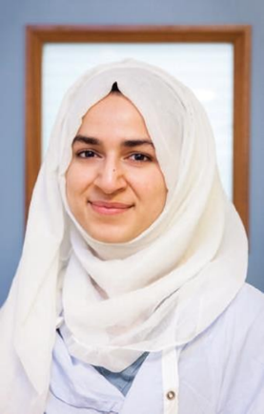

**In theatre**

Some Trusts permit students to wear a clean cloth hijab for each theatre attendance, which must be subsequently washed at 60oC, with or without an additional theatre cap. Alternatively, orthopaedic hoods or single-use disposable headscarves* may be worn.

*Modest medical wear such as disposable hijabs and sleeves may be purchased from: <https://britishima.org/wp-content/uploads/2021/12/Modest-Medical-Wear-Catalogue.pdf>

# **The Turban**

### Wearing the turban

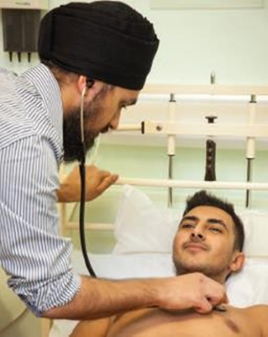Some Sikh students wear a turban for cultural or religious reasons.

**In theatre**

Some Trusts permit students to wear a clean cloth turban for each theatre attendance, which must be subsequently washed at 60oC, with or without an additional theatre cap head-covering when in surgical theatre. Alternatively orthopaedic hoods* may be worn.

# **The Yarmulke**

### Wearing the Yarmulke

Some male Jewish students wear a yarmulke for cultural or religious reasons.

**On placement**

Some Trusts permit students to wear a theatre head-covering to cover the yarmulke, when in surgical theatre.

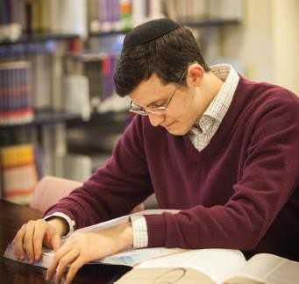

# **Face veil - Niqab and Burka**

### Face veil

As part of their religious or cultural observance, some female Muslims may wear a half face veil –

a niqab – or a full-face veil – a burka.

All students are required to clearly show their face in situations where this is important for communication with another person. A student’s face should be clearly visible in the following situations:

* In all clinical areas, except for clinical areas that require face masks to be worn
* When working with teachers
* When working with other students
* When examining a patient as part of an Objective Structured Clinical Examination (OSCE)
* or identification purposes including entry to examinations and the library
* When working in anatomical sciences laboratories or other licensed laboratories

During large lectures, when there is no expectation of interaction with every member of the class, students may cover their faces with a niqab or burka.

However, if it is considered that communication would be hampered in a learning environment – for

instance if facial cues are needed to understand a student’s contribution during small group discussions, role play, clinical skills or communication skills etc, then staff may request that an individual remove their face veil.

It is not permitted to wear a niqab or burka or any facial covering in secure areas of the university. A secure area is defined as any area that is managed by access control. Anyone who needs to use their ID card to gain access, may reasonably assume they have entered a secure area.

On placement, all students are expected to comply with each individual Trust’s dress code policy

regarding the niqab or burka.

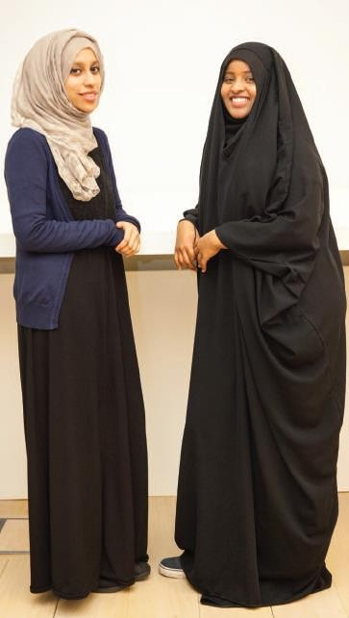

### Loose dress - The jilbab and the chador

Some female Muslims wear a jilbab – a loose dress from neck to ankle which covers the arms including the wrists or a chador (a full-body cloak). Please refer to section 1.1 for guidance regarding sleeves.

Students are expected to comply with each individual Trust’s dress code policy regarding the chador and jilbab.

# **Beards**

### Beards and Facial Hair

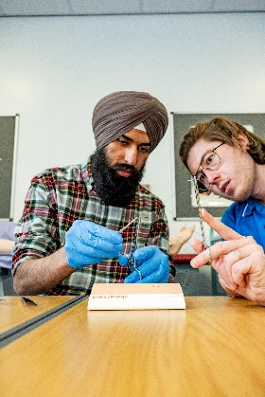Some males of Muslim, Sikh or Jewish faith may keep a beard as part of their religion. Beards and moustaches should be short and neatly trimmed unless this reflects the individual’s religion in which case the beard and/or moustache should be tidy.

In restricted areas, facial hair must be covered by an appropriate, single-use disposable theatre cap/hood. This should be changed if contaminated with blood or body fluids and at least daily or on leaving the theatre suite. Recent studies have shown that wearing cloth caps over facial hair in theatres reduces the risk of infection.

# **The Kara: Steel Bangle**

### The Kara

Both male and female Sikhs wear the Kara; a sacred bracelet made of steel. It is a religious requirement to wear the Kara. Sikhs are not permitted to remove the Kara.

**On Placement**

Sikh students should ensure their Kara is pushed up the arm and secured in place with tape for hand washing and during direct patient care activity

Some Trusts may allow students to tape up their Kara when in surgical theatre.



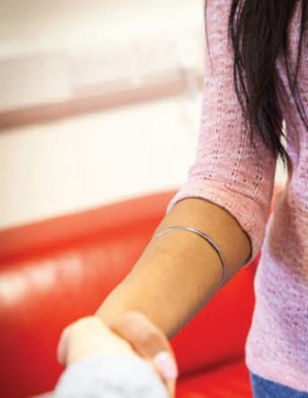

# **The Kirpan: Ceremonial Sword**

### The Kirpan

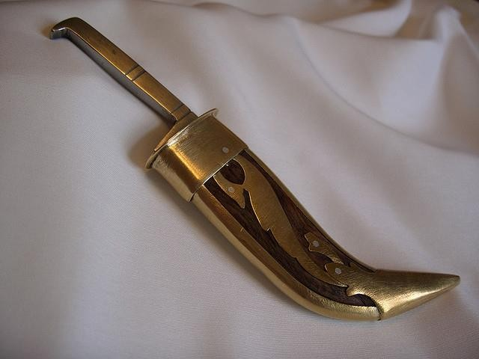A Sikh may be uninitiated or initiated. Initiated male and female Sikhs are required to wear the Kirpan (a ceremonial sword). The Kirpan is carried in a sheath attached to a cloth belt. It is normally worn discreetly under clothes and most people would be unaware that a Sikh person was carrying a Kirpan. The size of the Kirpan may differ depending on the personal taste of the initiated Sikh but may be only a few inches long.

Under the 1988 Criminal Justice Act, the Kirpan is **NOT** classified as an offensive weapon, and therefore Sikhs carrying the Kirpan are exempt from prosecution under the Offensive Weapons Act 2008.

The Faculty of Medicine recognises that initiated Sikhs have a right to wear the Kirpan. However, the institution is also mindful that not everyone is familiar with the full significance of the Kirpan. Therefore, as a compromise and to avoid undue alarm to others, when on campus, wearers of the Kirpan must ensure this item is worn discreetly, e.g., by tucking it inside clothes or inside a belt and covering that with clothes. Any student wearing a Kirpan should also ensure it is secured so it cannot be easily drawn.

**On Placement**

If the student needs to scrub in to take part in surgical theatre, then some Trusts may require that the student tape the Kirpan to their body.

# **Suitable clothing for laboratory work**

### Laboratory coats

Inside laboratories, students may be required to wear laboratory coats over their clothes and may be required to close the coat up completely.

### Trailing clothes

Apart from shoes, students must not wear any clothing that touches the floor as this could potentially pick up contamination from the floor surface, dangle in chemical or biological hazards, or become a trip hazard.

### Personal protective equipment

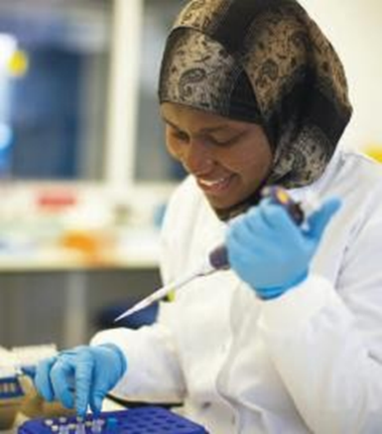Individuals working in laboratories must be able to wear the full range of personal protective equipment such as gloves, eye protection such as safety glasses or face shields, on occasion full face masks and in some areas a filtering face mask. For individuals with facial hair/beards alternative face coverings may be used. Head wear must allow individuals full frontal and peripheral vision at all times and must allow for communication in an unobstructed manner, especially during emergency situations or when alarms are sounding.

### Modest Medical Wear

Modest medical wear such as disposable hijabs and sleeves may be purchased from: <https://britishima.org/wp-content/uploads/2021/12/Modest-Medical-Wear-Catalogue.pdf>

# **Identification checks**

### ID Security checks – please also see section 7.1 (the Niqab and Burka)

The Faculty of Medicine appreciate that for religious or cultural reasons, some female students may choose to wear a facial covering when travelling around the campus. However, it is important that all students realise from time to time the institution may wish to verify the identity of an individual in order:

* To allow access to premises
* For the purposes of taking an examination
* To carry out a security check

This is usually done by carrying out a visual check against photographic ID issued by the University of Southampton.

**Obtaining a Photo ID**

For reasons similar to those outlined above, some female students may be uncomfortable having their photograph taken for their ID card. In this situation, it may be appropriate to have a female member of staff available to take the photo in a private room (if available).

If a female photographer is not available, an alternative may be that the member of staff or student with a facial covering provides a passport photo, which is then verified by a female member of staff in a private room and this photo is then scanned onto the ID card.

# **Taking part in medical procedures**

### Taking part in abortive procedures/human embryo/fertility treatments

If a student does not wish to participate in any attachments which use abortive procedures on human foetuses and other human embryo and fertility treatments, they can ask for a reasonable accommodation to be made.

**Blood transfusions**

Members of some religions such as Jehovah Witnesses are prohibited from receiving blood transfusions. However, to meet core competencies, any student training as a clinician at the University of Southampton will be expected to take part in procedures that involve taking blood from others – such training may not be avoided.

# **Practising your religion**

### Practising your religion

For those students who practice prayer, there are facilities provided on campus. There is a Muslim prayer room in Building 40, Highfield Campus, and Friday prayers are also held. The Chaplaincy is home to the multi-denominational Christian chaplains but welcomes staff and students of all faiths for prayer or to sit in quiet contemplation. There are both male and female prayer rooms available on placements across our partner Trusts - please check with your Placement Administrator.

If you wish to pray at certain times of the day while on Placement it is important that you make arrangements in advance with the Placement Coordinator/Administrator.

### Multifaith Societies

The University of Southampton is a diverse and lively community of many different faiths. The Chaplaincy is a place for people of all faiths to meet, and members of all student faith organisations and societies are welcome to use these facilities.

Please check the Chaplaincy web pages at [http://www.chaplaincy.soton.ac.uk/multifaith.php](http://www.chaplaincy.soton.ac.uk/multifaith.php%20) for more information on the various groups and societies.

More information can also be found at the following link:

<http://www.southampton.ac.uk/diversity/religion_and_belief/index.page?>

### Food on campus

Vegan, vegetarian and Halal food options are available at the SUSU shop and Building 42 on Highfield Campus. The University of Southampton does not currently provide Kosher food. People with special dietary needs are welcome to bring their own food with them.

**Food on placement**

Students with special dietary requirements which may include reasons of religious observance must be prepared to make their own arrangement regarding their food.

# **Keeping a record of each student’s request**

### Monitoring

Programme administrators will keep a record of all student requests for religious accommodations to be made on that student’s file. This information will include:

* The student’s programme
* The student’s religion or belief
* The nature of the accommodation requested
* If the accommodation was made, and how it was made
* If not, why not – and record the ‘objective justification’ to not making such an accommodation

# **Acknowledgements**

The Faculty of Medicine would like to thank the St. George’s University School of Medicine for allowing us to adopt and adapt this document. Thank you to all the students from St. George’s who allowed their photographs to be used. Thank you to Dr Azra Khatun and Sandal Butt for adapting and updating this version of the document.